List of Experiments

1. Time response of Second order system

2. Characteristics of Synchros

3. Programmable logic controller – characteristics of stepper motor

4. Effect of feedback on DC servo motor

5. Effect of P, PD, PI, PID Controller on a second order systems

6. Lag and lead compensation – Magnitude and phase plot

7. DC position control system

8. Transfer function of DC motor

9. Temperature controller using PID

10. Characteristics of magnetic amplifiers

11. Characteristics of AC servo motor

12. Characteristics of DC servo motor

13. Potentiometer as an error detector

1. TIME RESPONSE OF THE SECOND ORDER SYSTEM

AIM: To study the characteristics of first order of the linear system.

APPARATUS: 1. CRO.
2. Probes.
3. LSS kit.

BLOCK DIAGRAM OF FIRST ORDER SYSTEM:

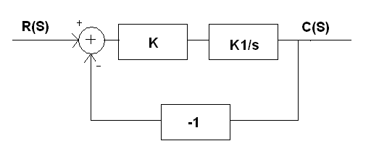
RESPONSE OF FIRST ORDER SYSTEM:

BLOCK DIAGRAM OF SECOND ORDER SYSTEMS:

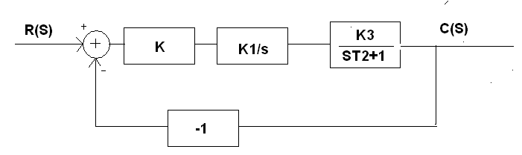

RESPONSE OF SECOND ORDER SYSTEM:

PROCEDURE:

I.Fisrt Order system:

- Two forms of first order closed loop system are possible make proper connections for the configuration chosen.

- Apply a 1V peak to peak square input and trace the output waveform on a tracing paper for K=0.5, 1.0, 1.5………. calculate the time constant in each case and compare with theoretical results.

- If the open loop transfer function in the chosen configuration was of type 1, the steady state error above would be zero for a step input. To find steady state error for ramp input, apply a 1 volt peak-peak triangular wave input. Keeping the CRO in X-Y mode, connect system input to the X input and the system output to Y input. A trace will be on the CRO in which the vertical displacement between the two curves is the steady state error.

- Repeat the measurement ofr steady state error for different values of K and compare the result with theoretical.

- Note that in case of first order type-1 system experiments must be conducted at the lowest frequency to allow enough time for the step response to reach near stady state for still better results an external oscillator may be used.

II.Second order system:

- Connect the second order system by considering the first block diagram.

- Apply a 1volt peak-peak square wave input.

- Trace the output peak waveform on trace paper for different value of ‘K’.

- Obtain peak percent overshoot, settling time, rise time and steady state error from the fracing and calculate and ω_{n} compare with theoretical results.

- Take the second block diagram and repeat the steps.
PRECAUTIONS:

- Avoid loose connections and check before the circuit is ON.

- Take the reading carefully.

- Observe the waveform clearly in the CRO.

RESULT:

2. CHARACTERISTICS OF SYNCHROS

AIM: To obtain characteristics of Synchro Transmitter & Receiver.

APPRATUS REQUIRED:

1) Synchro Transmitter & Receiver Trainer Kit.
2) Multimeter.

FRONT PANEL DIAGRAM:
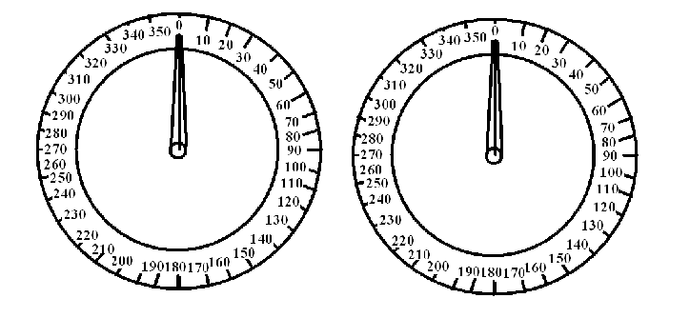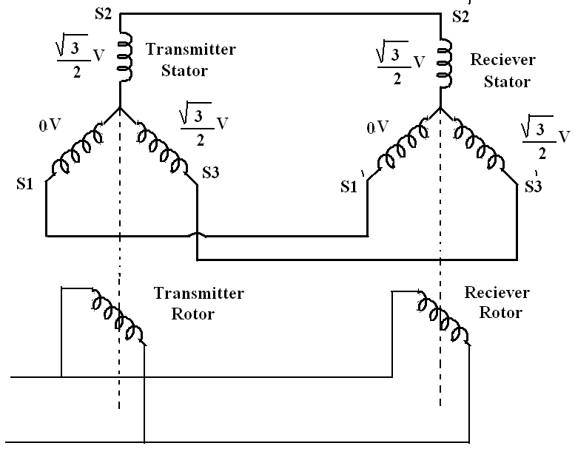
PROCEDURE:

I.STUDY OF SYNCHRO TRANSMITTER

- Connect the mains supply to the system with help of cable provided .Don’t connect any patch cards to the terminal marked s₁,s₂,s₃ .

- Switch on mains supply for the unit.

- Started from zero position, note down the voltages between stator winding terminals i.e V s₁,s₂, V s₂, s₃, & V s₃, s₁ in a sequential manner.enter the reading in a tabular form and plot a graph of angular position of rotor voltage for all the three phases.

- Note that zero position of the rotor coincides with V s₃, s₁ voltage equal to zero voltage.

TABULAR FORM:

S.no | Rotor position (degree) | RMS voltage for Stator terminal  V s₃, s₁ | RMS voltage for Stator terminal  V s₁,s₂ | RMS voltage for Stator terminal  Vs₂, s₃
1
2
3
4
5
6
7
8
9
10
II.STUDY OF SYNCHRO TRANSMITTER AND RECEVIER PAIR:

1) Connect main supply cable.

2) Connect s₁,s₂,s₃ terminals of transmitter to s₁,s₂,s₃ of Synchro receiver by patch cards provided respectively .

3) Switch on Sw1 & Sw2 and also switch on the mains supply.

4) Move the pointer i.e, motor position of Synchro transmitter Tx in steps of 30 Deg and observe the new rotor position observe that when ever Tx rotor is rotated. The Tr rotor follows it for both the directed of rotations and their position are in good agreement.

- Enter the input angular position and output angular position in tabular form and plot graph.

TABULAR FORM:

S.no | Angular position in Deg  Synchro transmitter input | Angular position in Deg  Synchro receiver output
1
2
3
4
5
6
7
8
9
10
11
PRECAUTIONS:

- Handle the pointer for both the rotor the motor in gentle manner.
- Do not attempt to pull out the pointers.
- Do not short rotor (or) stator terminals.

RESULT:

3. PROGRAMMABLE LOGIC CONTROLLER

AIM : To verify logic gates using programmable logic controller.

APPARATUS:

- Programmable logic controller kit.
- Personal computer.

THEORY:

LOGIC GATES:

AND GATE:

An AND gate has two or more inputs but only one output at gate also called as all or nothing gate . The operation of AND gate is as follows.

- When both the inputs are high ,then the output is high
- If one of the inputs is high or low, then the output is low.
- When both the input is low, then the output is low.

OR GATE:

An OR gate can have two or more inputs but only one output. OR gate is also called as any or all gate .It is also called as inclusive OR gate, both the inputs can be3 present .The operation of OR gate is as follows.

- When both inputs are high, then the output is high.
- If one input is high or low, then the output is high.
- When both inputs are low, then the output is low.

NOT GATE:

This gate is also called an inverter; it has only one input and only one output. It is a device whose output is always a complement of input. The operation of NOT gate is as follows.

- When the input is high, output is low.
- When the input is low, output is high.

UNIVERSAL GATES:

NAND: operation as follows
a) When both inputs are low, then the output is high.
b) When any one of input is high or low, then the output is high.
c) When both inputs are high, then the output is low.

NOR: operation as follows
a) When both inputs are low, then the output is high.
b) When any one of input is high or low, then the output is low.
c) When both inputs are high, then the output is low.

BLOCK DIAGRAM OF PLC:

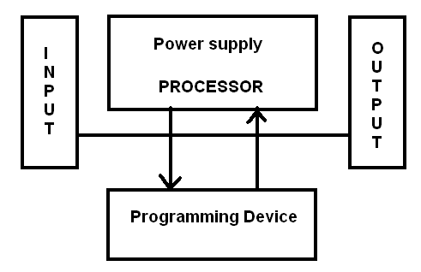

Ladder Diagram of AND gate Ladder Diagram of OR gate.

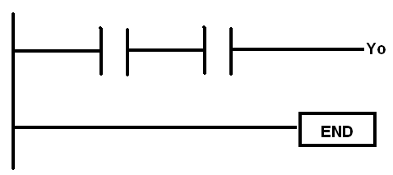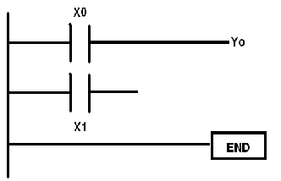

Ladder Diagram of NOT gate.

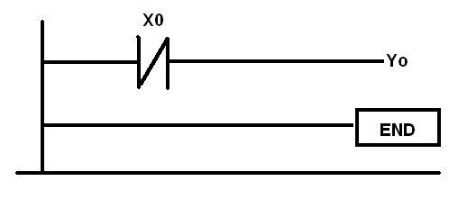

Ladder Diagram of

NAND gate. NOR gate. HALF SUBTRACTOR

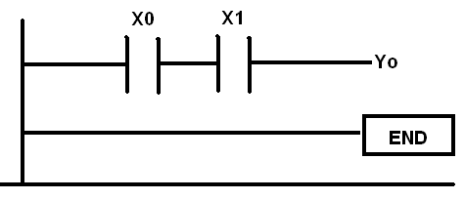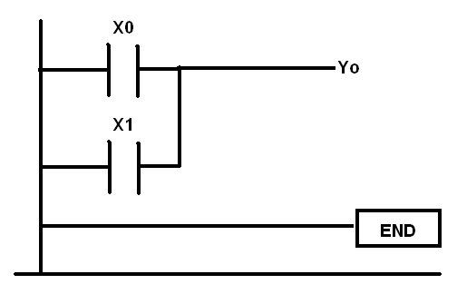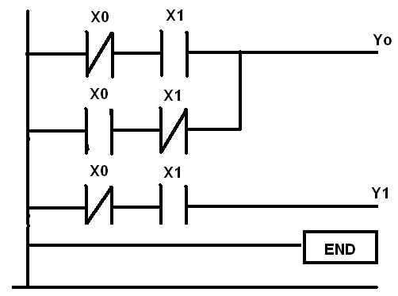

Ladder Diagram of FULL ADDER. Ladder Diagram of FULL SUBTRACTOR

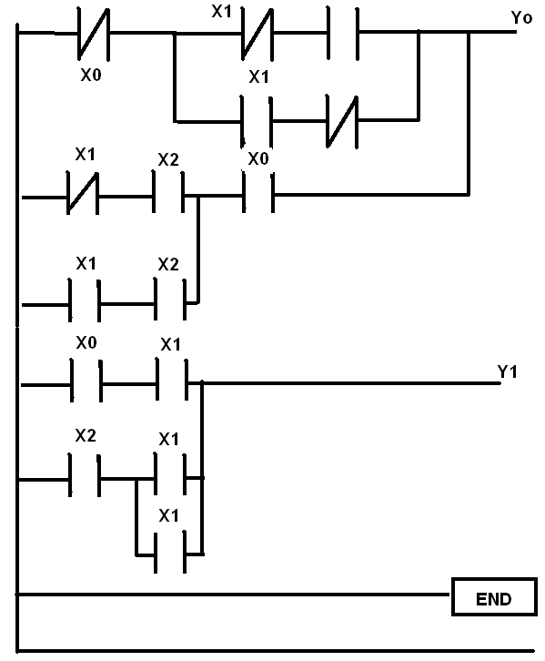
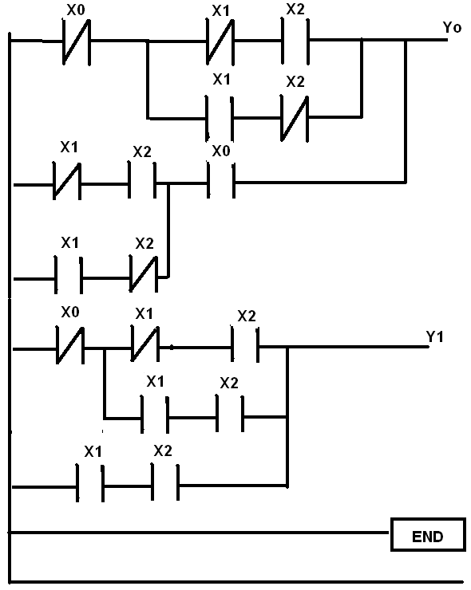

Ladder Diagram of COMPARATOR
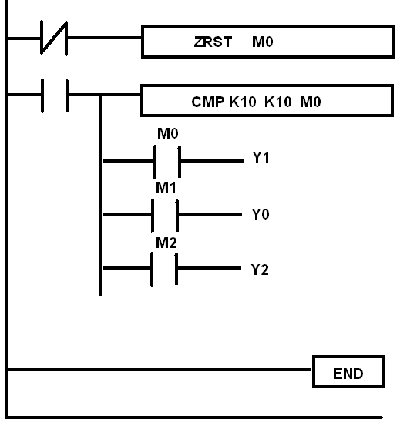

PROCEDURE:

I. TO VERIFY LOGIC GATES USING PLC:

WRITING THE PROGRAM:

- Wp 12.06 works on all windows plat forms.

- Open Wp 12.06 softwware from program menu.

- Open new project from menu bar.

- Select required symbols from ladder tool bar and place them on working area.

- After writing the program, save the program.

COMPILATION OF THE PROGRAM:

- After saving the program press ‘crlt+F9’ for compilation.

EXECUTE THE PROGRAM:

- Go to ‘Communication’ menu by pressing ‘Alt+C.

- Select “Pc⬄Plc” option.

- In the displayed window select write PLC option, press Enter.

- It displays no error message.

- Next select run PLC from communication menu to execute the program.

II. TO VERIFY UNIVERSAL GATES USING PLC:

WRITING THE PROGRAM:

- Wp 12.06 works on all windows plat forms.

- Open Wp 12.06 softwware from program menu.

- Open new project from menu bar.

- Select required symbols from ladder tool bar and place them on working area.

- After writing the program, save the program.

COMPILATION OF THE PROGRAM:

- After saving the program press ‘crlt+F9’ for compilation

EXECUTE THE PROGRAM:

- Go to ‘Communication’ menu by pressing ‘Alt+C’.

- Select “Pc⬄Plc” option.

- In the displayed window select write PLC option, press Enter.

- It displays no error message.

- Next select run PLC from communication menu to execute the program.

III. TO VERIFY ADDER, SUBTRACTER & COMPARATER USING PLC.

WRITING THE PROGRAM:

- Wp 12.06 works on all windows plat forms.

- Open Wp 12.06 softwware from program menu.

- Open new project from menu bar.

- Select required symbols from ladder tool bar and place them on working area.

- After writing the program, save the program.

COMPILATION OF THE PROGRAM:

- After saving the program press ‘crlt+F9’ for compilation

EXECUTE THE PROGRAM:

- Go to ‘Communication’ menu by pressing ‘Alt+C’

- Select “Pc⬄Plc” option.

- In the displayed window select write PLC option, press Enter.

- It displays no error message.

- Next select run PLC from communication menu to execute the program.
PRECAUTIONS:

- Apply high or low to input terminals.

- Don’t give any external power supply to input.

- Don’t short any internal connections between input and output.

- Before writing program to PLC, be sure that PLC is in Stop mode.

RESULT:

4. DC SERVO MOTOR SPEED TORQUE CHARACTERISTICS

AIM: To plot the speed torque characteristics of DC servomotor.

APPARATUS: 1) DC Servomotor kit.
2) Multimeter.

FRONT PANEL DIAGRAM:

PROCEDURE:
- Before switch on the instrument, the speed control plot and the load control plot are in fully anti clock wise position.
- Keep the load switch and motor switch in off position.
- Now switch on the instrument, switch on servomotor.
- By using potentiometer P1 set armature voltage (Va) at fixed Va using digital multimeter to measure armature voltage at front panel at Tp1 and note down speed of DC servo motor in Table.
- Now keep P2 at minimum position and switch on the load .switch to apply load on DC servomotor .Note down corresponding current from Dc ammeter. And also note down back emf from Tp3 terminal by using multimeter .Enter the values corresponding the RPM value.
- Repeat step no.5 for different values by varying load control potentiometer p2 in a slow fashion. Note down corresponding values of current Ia, Back emf voltage Eb & Speed N and enter the values in table.
- Now switch off load switch and keep P2 in minimum position & again set armature voltage, Va= Again repeat process indicated in steps 5 & 6.
- Repeat the process in 5, 6, 7 at different values Va and plot the graph speed verses torque of various values of Va.
- Before switching on check that there should be proper earthning and proper connections.
- The speed contol and load control potentiometers should be always in anticlock wise position before switching on the equipment.
- In order to increase armature voltage rotate the knob in clockwise direction in gentle fashion.
- In order to increase load on servomotor .Rotate load control pot in clock wise direction in gentle fasion.
- Before doing experiment check armature voltage and DC machine voltage at Tp1 & Tp3 terminals.
TABULAR FORM:

Armature Voltage Va =4V

S.No | I_{a}  (Amps) | N  (rpm) | Back EMF voltage Eb(V) | Power  P=E_{b}xI_{a}(mw) | Torque  T= (Px1.019x10⁴x60)  2πN (gm-cm)
1
2
3
4
5
6
7
8

Armature Voltage Va =6V

S.No | I_{a}  (Amps) | N  (rpm) | Back EMF voltage Eb(V) | Power  P=E_{b}xI_{a}(mw) | Torque  T= (Px1.019x10⁴x60)  2πN (gm-cm)
1
2
3
4
5
6
7
8
Armature Voltage Va =8V
Armature Voltage Va =10V
S.No | I_{a}  (Amps) | N  (rpm) | Back EMF voltage Eb(V) | Power  P=E_{b}xI_{a}(mw) | Torque  T= (Px1.019x10⁴x60)  2πN (gm-cm)
1
2
3
4
5
6
7
8
S.No | I_{a}  (Amps) | N  (rpm) | Back EMF voltage Eb(V) | Power  P=E_{b}xI_{a}(mw) | Torque  T= (Px1.019x10⁴x60)  2πN (gm-cm)
1
2
3
4
5
6
7
8

MODEL GRAPH:
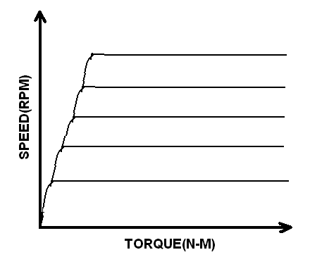

PRECAUTIONS:
- Before switching ON check that these should be proper earthing & proper connections.
- The speed control & Load control potentiometers should be always in anticlockwise position before switch on equipment.
- Before doing experiment check armature voltage and DC machine voltage at Tp1 & Tp3 terminals.

RESULT:

5. EFFECT OF P, PD, PI, PID CONTROLLER

AIM : To study the performance characteristics of an analog P & PI controller using simulated systems.

APPRATUS: 1) PID controller kit.
2) CRO.
3) Probes.

BLOCK DIAGRAMS:

Connection diagram for P Control :

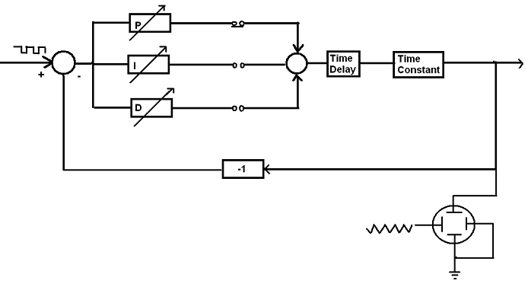
Connection diagram for PI Control :
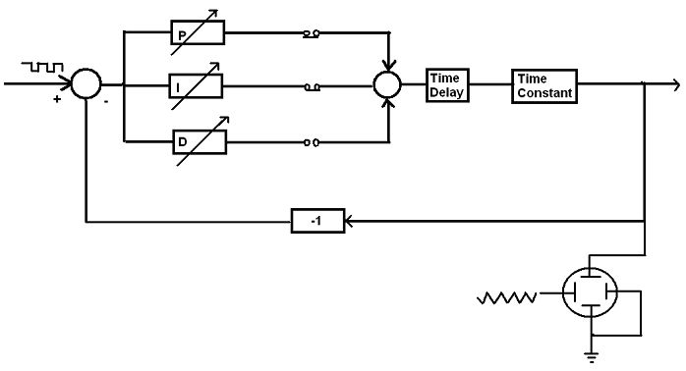

Connection diagram for PID Control :

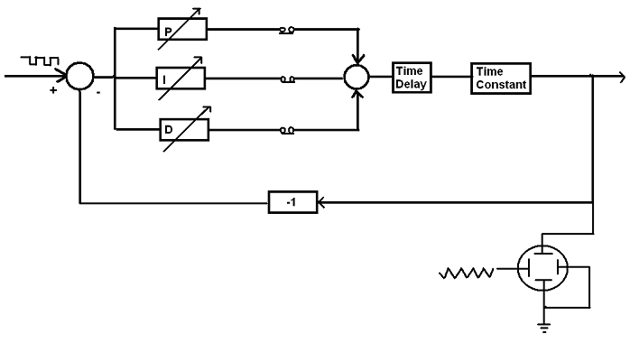

PROCEDURE:

1)PROPORTIONAL CONTROL:

a) Make connections this process made up of time delay and time constant blocks noticed that the CRO operates in the X-Y mode ensures stable display at low frequencies.

b) Set input amplitude 1V,peak –peak and frequency to a low value.

c) For various values of Kc=0.2,0.4……. measured from the screen .the value of the peak overshoot & steady state error and tabulate the simultaneous display of square wave input in the system response using a dual trace oscilloscope may be used to get a very clear idea of the transient and steady state performance and flickering may however be observed in the case due to the low frequency involved.

2) PROPORTIONAL-INTEGRAL CONTROL:

The integral terms result in increasing the system type number by unity and those causes improvement in steady state performance. To verify the above step, input one starts with a type-0 system having non –zero error. Introducing a PI control with a properly selected value of Ti should reduce the error to zero.
The steps suggested are as follows.

- Make connections for 1st order type-0 system with time delay.

- Set input amplitude 1V P-P value to a low frequency and K_{i} to 0.

- For K_{L} =0.6 observe & record the peak overshoot and steady state error.

- With K_{L} as above, increase K_{i} in small steps and record peak overshoot and steady state error.

3) PROPORTIONAL-INTEGRAL-DERIVATIVE CONTROL:

This experiment demonstrate the improvement in transient performance, following steps are suggested.

- Make connections as shown in figure with proportional integral & derivative blocks connected.

- Set input amplitude with 1 V p-p frequency low value, K_{L}= 0.6,K_{i} =54.85 and K_{d}=0

- The system shows a fairly large overshoot, Repeat the above step for a few non-zero values of Kd

- For K_{L}= 0.6, adjust K_{i} & K_{d} by trail & error to obtain the best overall response.

PRECAUTIONS:

- Connect the probes without any loose connections.

- Draw the graph without any error.

- The instrument should be handled properly.

- Do not touch any terminals on front panel with hands.

RESULT:

6. LAG & LEAD COMPENSATION –MAGNITUDE AND PHASE PLOTS
AIM: To study the performance characteristics of lag network and lead network.
APPARATUS:
1) Lead-Lag compensation kit.
2) CRO.
  - Probes.
  - Resistors.
  - Capacitors.

FRONT PANEL DIAGRAM:

PROCEDURE:

i)Performance characteristics of lag compensator:

1) Switch ON the supply.
2) Select the components R1=10K, R2=10K & C=0.22µF.
3) Make connections as shown as to form a lag compensation network.
4) Using the CRO in X-Y mode, give input of network to X-input of CRO & output of network to Y-axis of CRO.
5) Set the sine wave amplitude at 3V.
6) Now vary the frequency, from 25Hz to 1000Hz in steps and note down readings in table.
7) Calculate gain and phase difference from readings.
8) Now calculate theoretical value of gain & phase difference from formulae.
9) Now repeat the experiment by connecting a load resistor of 10K between output and ground.Because of loading characteristics of network changes drastically.
10) To avoid loading, an amplifier may be connected between the network & load. Now repeat the experiment by connecting an amplifier between network & load.
a) Connect output of network to input of amplifier .
b) Connect the load resistor of 10K between output of amplifier & ground.
The characteristic will be similar without load & with load.
11)form the equipment without load & with load, with amplifier & without amplifier.Notedown the readings in tabular form.

ii)Performance characteristics of lead compensator:

1) Switch ON the supply.
2) Select the components R1=10K, R2=10K & C=0.22µF.
3) Make connections as shown as to form a lead compensation network.
4) Using the CRO in X-Y mode, give input of network to X-input of CRO & output of network to Y-axis of CRO.
5) Set the sine wave amplitude at 3V.
6) Now vary the frequency, from 25Hz to 1000Hz in steps and note down readings in table.
7) Calculate gain and phase difference from readings.
8) Now calculate theoretical value of gain & phase difference from formulae.
9) Now repeat the experiment by connecting a load resistor of 10K between output and ground. Because of loading characteristics of network changes drastically.
10) To avoid loading, an amplifier may be connected between the network & load. Now repeat the experiment by connecting an amplifier between network & load.
a) Connect output of network to input of amplifier .
b) Connect the load resistor of 10K between output of amplifier & ground. The characteristic will be similar without load & with load.
11) Perform the equipment without load & with load, with amplifier & without amplifier.Notedown the readings in tabular form.

PRECAUTIONS:

1) Avoid the loose connections.

2) Plot the graphs without any error.

RESULT:

7. DC POSITION CONTROL SYSTEM

AIM:-To study the performance characterstics of a dc motor angular position control System.

Apparatus : 1) DC Position Control System Kit
2) Rotor position controller

THEORY :

NEED FOR STABILIZATION:-
With tachogain pot in zero position, the step change in input shaft, output exhibits anoscillating behaviors. This happens because of the system elements which are capable of storing energy i.e. capacitance, inductance, inertia of moving components like rotor of motor laod gera train etc..
Once the system is excited by a change in the input signal the various elements begin to store energy and even if the error voltage falls to zero, the stored energy causes the output shaft to move in the same direction. This creates an error of opposite polarity and the system again is instructed to work in the opposite direction. In this way energy storing elements tend to produce over shoots and under shoots in the system. For avoiding this various stabilizing techniques are used. In this step up ‘DERIVATIVE FEEDBACK’ is used fo stabilizing of the output.
The techo generator which is coupled to the motor generates an output voltage which is proportional to the rate of change of ϴ2 i.e.. v-tach =.This voltage is coupled to the input error amplifier in regenerative mode or deregenerative mode by adjusting tacho gain pot ,the amount of derivative feedback can be adjusted while the DPDT switch is meant for selection of the maode of stabilizing feedback.

HOW DERIVATIVE FEEDBACK WORKS?
When SW1 is in downward position (in tachyon position),and SW2 also in downward position, and the degenerative_(-ve) feedback is suitably adjusted we observe that the output shaft fallows the input shaft in a smooth fashion without any unwanted oscillations.
If the mode of feedback is regenerative (+ve) then the output never reaches a stable state, instead it keeps on oscillating around the desired position. In short for degenerative feedback the damping factor of the system is increased this resulting in braking action on the moving components prior to their final desired position. Hence, there are no oscillations. For a greater amount of feedback voltage, damping becomes excessive and system exhibits a very sluggish response.
For regenerative feedback the damping of the system, is reduced the energy stored in. The moving elements cannot be readily dissipated .This increases the tendency for oscillations and the system becomes unstable. Please note that this is never a desirable way of operation.
OPERATING INSTRUCTION:
(1).Before switching on the mains, see that the switches SW3,SW4(on the LHS panel) are in down ward position i.e. ON position.
(2) keep the input potentiometer P1 in 10 degree position.
(3)Adjust the potentiometer P3(amplifier gain Adj.) in mid position.
(4) now switch ON the main unit LED ‘R’ and LED”G” should glow.
OPERATION WITHOUT STABILIZING FEEDBACK or open loop(SW1 in off position i.e. tacho out):
- Now slowly advance the input potentiometer P1 in clockwise direction. The output potentiometer along with load will be seen to be fallowing the change in the input potentiometer.
- When the input is disturbed, the null indicator will be showing some indication but when it may be noted that when input pot is moved in anticlockwise Direction, the output pot P2 also moves in the reverse direction
STEP CHANGE INPUT :
Keep the pot P1at around 180 degree position.pot P2 also will be in the same position.
Now change the input pot in the step fashion by about 60 to 80 degrees(in fact approximating step input), The output will be observed to change in oscillatory mode before
it settles to a final position. The tendency for oscillations is found to be dependent on the amplifier gain setting. For high gain there are too many oscillations where as low gain oscillations are reduced but with static error.
OPERATIONS WITH STABILIZING FEEDBACK(closed loop):
Now put the SW1 switch in lower position .i.e, TACHO IN position.SW2 must be in downward position i.e, degenerative mode. Keep P4 in fully anti clockwise direction ,output again indicates oscillations.
- Now take the pot P1(input potentiometer)to 180⁰ position, effect the step input change in one of the direction ,output again indicates oscillations.
- Now advance the tachogain pot P4 in clockwise direction the output now is observed to follow the input in smooth fashion without oscillations. If the tachogain pot P4 is too much advanced ,the output now fallows input in a sluggish fashion indicating over damped system. Now take the pot P1 to 180 degree position.
- Now the switch SW2 in upward position i.e. regenerative mode .Now if the port P1 is disturbed, the output pot P2 is found to oscillate continuously around desired position .As the amount of feedback is adjusted the frequency and amplitude of output is observed to vary.
- Bring the switch SW2 in down ward position.

- Warning:- Do not operate the DC position control in the regenerative mode for long time. This can damage the potentiometers.

TABULAR COLOUMS:
Without stabilizing feedback

SL NO | Input angular position in degrees | Output angular position in degrees | Remarks

Note that these are typical readings and there can be piece to piece variation because the servometer pots are having linearity of +/_1%/It is better to operate in the region of 15 degrees to 330 degrees to avoid zero crossing and possible damages of potentiometer.

WITH NEGATIVE FEEDBACK

SL NO | Input angular position in degrees | Output angular position in degrees | Remarks for SW2 in degenerative mode

WITH POSITIVE FEEDBACK

SL NO | Input angular position in degrees | Output angular position in degrees | Remarks for SW2 in Regenerative mode

Precautions:
- Heating and possible damage of the power stage.
- Do not operate this mode for long time.

RESULT:-

8. TRANSFER FUNCTION OF DC MOTOR

AIM: To study the characteristics of DC motor and DC generator, DC motor speed-torque characteristics, step response of DC motor.

APPARATUS:
1) DC Motor & DC Generator trainer kit.
2) Digital Voltmeter.
3) Patch Cards.

FRONT PANEL DIAGRAM:

PROCEDURE:

- DC Motor & DC Generator Characteristic:

  - Connect the patch cards as shown in diagram
  - Set ‘Motor’ switch to ‘ON’ set ‘RESET’ switch to ‘RESET’ set ‘LOAD’ switch to O position.
  - Vary Ea in small steps and take readings
  - E_{G}( Generator Voltage can also be observed at DC voltmeter and I_{a} can be observed at DC ammeter.
  - Obtain slopes and complete K_{M} ( Motor Gain Constant) and K_{G}(Generator Gain Constant) by using

K_{M} = N/E_{a RPM}/Volt = Π N
30 E_{a}

K_{G}= E_{g}/N Volt/rpm = 30 E_{a}
Π N
6) Now Plot N (Speed ) vs E_{a} ( Armature Voltage) & Eg (Generator Voltage) vs N (Speed ).
7) Take average values of K_{M} (Motor gain constant) and K_{G} ( Generator gain constant).
TABULAR FORM:
S.No | E_{a}(Volts) | I_{a}(Amps) | N(RPM) | E_{g}(Volts)
1
2
3
4

MODEL GRAPH:

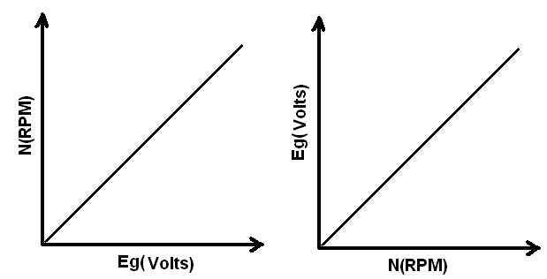

- Torque- Speed characteristics:

1)Set ‘Motor’ switch to ‘OFF’, Set ‘RESET’ switch to ‘RESET’, set ‘LOAD’ switch to O Position.
2) Connect Ea to the voltmeter and set some value.
3) Shift the ‘Motor’ switch to ‘ON’ position & Measure armature voltage (E_{a}) ,
Motor current (Ia) and motor speed in rpm .Record readings.
4) Set the ‘LOAD’ switch to 1,2,…5 and take readings ,Complete the table with
Calculated values.
5) Plot Torque vs speed curves on a graph.
6) Complete B from slope of torque –speed curve & average K_{b} (Back emf constant)
B= Tm(Motor torque) N-m
ω rad/sec
K_{b} = E_{b} / ω Volts
rad/sec
7) Repeat above for different Ea values & Record average value of motor parameters B & k_{b}

TABULAR FORM:
S.No | Load  step | I_{a}  (Amps) | N  (rpm) | ω=(2πN)/60 | E _{b}=E_{a}-I_{a}R_{a} | K_{b}=E _{b}/ ω | T_{M}=K_{b}I_{a}
1
2
3
4
5
6

MODEL GRAPH:

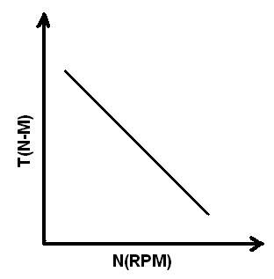

- Step Response:

1) Set ‘Motor’ switch to ‘OFF’, Set ‘RESET’ switch to ‘RESET’, set ‘LOAD’ switch to O position.
2) Connect Ea to the voltmeter and set some value.
3) Switch ‘ON’ the motor & measure Eg & steady state motor response i.e speed N, Respectively.
4) Set Es to 63.2% of Eg Measured above .This is the generator voltage at which counter will stop counting.
5) Switch ‘OFF’ the motor –set ‘RESET’ switch to ‘READY’.
6) Switch the motor ‘ON’. Record the counter reading as time constant to milli seconds.
7) Repeat above for different Ea values.
8) Substitute the value of K_{M} &T_{M} and write down the motor transfer function.
9) Using average values of Tm, B, Kb & R_{a.} Calculate motor inertia
J = T_{M} [B+K_{b}²/R_{a}]
10) Motor Transfer function is G(s) = W(s)/E(s) = K_{M} / (sT_{m}+1).
11) For generator: Repeat the above procedure & take generator Eg value.
12) Calculate average values to T_{M,}B ,K_{b}& R_{a}.Calculate generator inertia.
J = T_{M} [B+K_{b}²/R_{a}]
13) Generator Transfer function is G(s) = W(s)/E(s) = K_{M} / (sT_{m}+1).

TABULAR FORM:
S.No | E_{a}  (Volts) | E_{g}  (Volts) | N  (RPM) | E _{s}=0.632 E_{g} | Time constant T_{m}(ms) | K_{g}=(πN)  (30 E_{a})  Gain Constant
1
2
3
4
5

MODEL GRAPH:

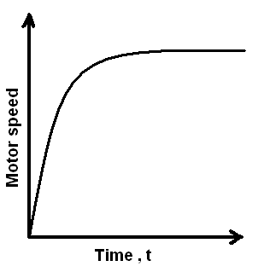
PRECAUTIONS:

- Avoid the loose connections.
- Take the readings carefully.
- Plot the graphs without any error.
- Check whether the load is in minimum position before switching on the motor.
RESULT:

9. TEMPERATURE CONTROLLER USING PID

AIM: To study the performance of various types of controllers used to control the temperature of the
oven.

APPARATUS:

1) Temperature control system. 2) Oven. 3) Multimeter. 4) Connecting wires.

PROCEDURE:

Identification of oven parameters

- Keep S₁ to wait ,S₂ to set the open feed back terminals.
- Connect P output to the actuator input and switch on the unit.
- Set ‘P’ potentiometer to 1 (maximum) which gives K_{p}=10. Adjust the reference potentiometer to read 5.0 on the DVM. This provides an input of 0.5v to driver.
- Put switch S₂ to measure position note down room temperature.
- Put switch S₁ to RUN position and note temperature readings every 15 sec, till temperature become constant.
- Plot the temperature-time curve.
- Calculate K (Oven temperature at steady state input)
Input=0.5v
G(S) =kexp(-ST₂)/(1+ST₁) T in ⁰C
ON-OFF Controller:
- Switch S₁ to wait position and allow oven to cool to room temperature.
- Keep switch S₂ to SET position and adjust reference potentiometer to the desired output temperature say 55⁰C, select high value of hysterics.
- Connect R output to controller input.
- Switch S₂ to ‘Measure’ position and S₁ to ‘RUN’ position Read and record oven temperature every 15/30 sec for about 20 min.
- Plot a graph between temperature and time.
- Repeat above procedure for low hystersis.

TABULAR FORM:
PROPORTIONAL-INTEGRAL CONTROLLER:
S.No | Temperature  (degrees) | Time  (sec)
1
2
3
4
5
6
7
8

- Calculate K_{p}
- Starting with a cool oven switch S₁ to wait, connect P and I output to actuator, set above values for P and I.
- Select and set desired temperature to say 55⁰C.
- Switch S₂ to ‘RUN’ position and record temperature verses time.
- Plot the response on graph and observe steady state error and percent overshoot.
PROPORTIONAL CONTROLLERS:

- Calculate K_{p.}
- Starting with a cool oven, switch S to WAIT position and connect P output to actuator input. Short feed back terminals.
- Set P potentiometer to above calculated value.
- Select and set the desired temperature to say 55⁰C.
- Switch S₁ to ‘RUN’ position and record temperature verses time.
- Plot the observations on linear graph paper and observe rise time, steady state error and percent overshoot. Therefore values of T₁ & T₂ are obtained from the graph.
TABULAR FORM:
PROPORTIONAL-INTEGRAL-DERIVATIVE CONTROLLER:
S.No | Temperature  (degrees) | Time  (sec)
1
2
3
4
5
6
- Calculate K_{p ,}K_{I,}K_{D}
- Starting with a cool oven, switch S to WAIT position and connect P output to actuator input. Short feed back terminals.
- Set P potentiometer to above calculated value.
- Select and set the desired temperature to say 55⁰C
- Switch S₁ to ‘RUN’ position and record temperature verses time.
- Plot the observations on linear graph paper and observe rise time, steady state error and percent overshoot. Therefore values of T₁ & T₂ are obtained from the graph.
TABULAR FORM:
S.No | Temperature  (degrees) | Time  (sec)
1
2
3
4
5
6
7
8
9
10

PRECAUTIONS: 1) Avoid the loose connections
2) Take the readings carefully.
3) Plot the graphs without any error.
RESULT:

10.CHARACTERISTICS OF MAGNETIC AMPLIFIER

AIM : To observe the characteristics of a series connected ,parallel connected ,self saturation magnetic amplifier.

APPARATUS : 1)Magnetic amplifier trainer kit.
2) Patch cards.
3) CRO.

CIRCUIT DIAGRAM:

SERIES CONNECTED MAGNETIC AMPLIFIER:

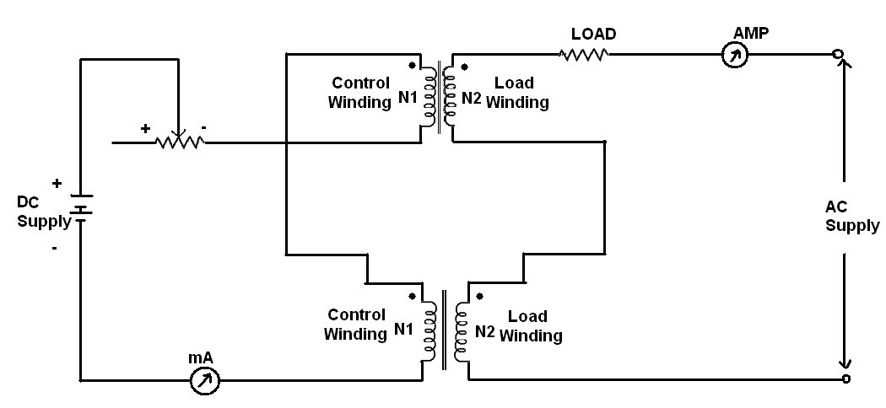
PARALLEL CONNECTED MAGNETIC AMPLIFIER:
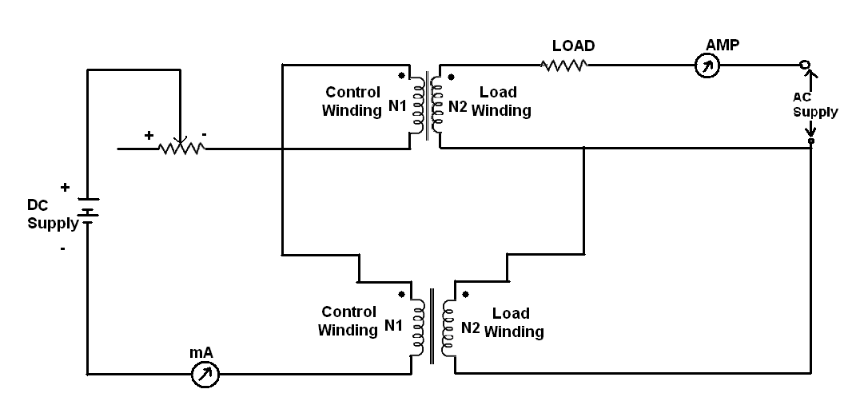

SELF SATURATED MAGNETIC AMPLIFIER:
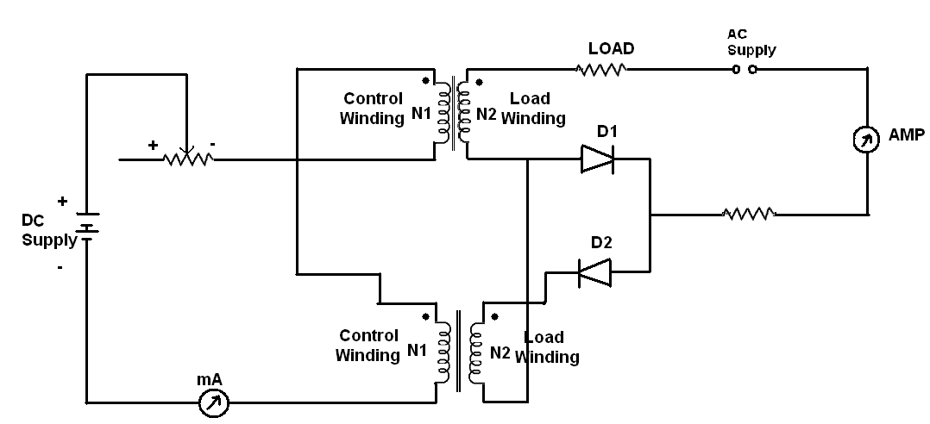

PROCEDURE :

I. SERIES CONNECTED MAGNETIC AMPLIFIER:

- Keep toggle switch I position ‘D’ on the front panel.

- Keep control current setting knob at its extreme left position which ensures zero control current at starting.

- With the help of patch cards ,connect the following terminals on the front panel of the unit
a) Connect AC to A1
b) Connect B1 to A2
c) Connect B2 to L

4) Now put the 100W lamp load in the holder provided on the front panel.

5) Now once again check the switch position and wiring.

6) Switch on the unit.

7) Now, gradually increase control current by rotating control current setting knob in clockwise direction in steps and note down the control current and load current.

8) Plot the graph of load current verses control current.

9) Take control current that is I_{C} on X-Axis and load current that is I_{L} on Y-axis.

- Now, Plot the graph with the above instructions.

TABULAR FORM :

S.No | Control Current (mA) | Load Current  (mA)
1
2
3
4
5
6
7
8

MODEL GRAPH:

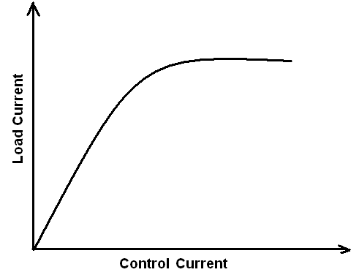

II. PARALLEL CONNECTED MAGNETIC AMPLIFIER

1) Keep the toggle switch in position ‘0’ on the front panel.

2) Keep the control current setting knob at its extreme left position which ensures zero control at starting .

3) Wire the unit as given below with patch cards

a) Connect A1 to Ac
b) Connect A1 to A2
c) Connect B2 to L
d) Connect B2 to B1

4) Connect 100 watt lamp load in the holder provided for this purpose.

5) Switch on the unit.

6) Now, gradually increases control current by rotating control current setting knob clock wise in steps and note down control current and load current.

7) Plot the graph of lolad current versus control current.

TABULAR FORM:

S.No | Control Current Ic(mA) | Load Current I_{L}(mA)
1
2
3
4
5

MODEL GRAPH:
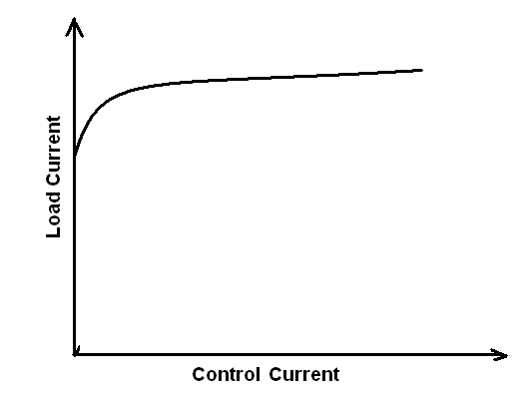
III. SELF SATURATED MAGNETIC AMPLIFIER:

1) Keep the toggle switch in position ‘0’ on the front panel.

2) Keep the control current setting knob at its extreme left position which ensures zero control at starting.

3) Wire the unit as given below with patch cards
a) Connect Ac to C
b) Connect A3 to B3
c) Connect B2 to L
4) Connect 100 watt lamp load in the holder provided on the front panel.

5) Now once again check the in position E and the connections.

6) Switch ‘on’ the circuit.

7) Now, increases control current by steps and note down Ic & control current.

8) Plot the graph of load current reuses control current.
TABULAR FORM

S.No | Control Current Ic(mA) | Load Current IL(mA)
1
2
3
4
5

.

MODEL GRAPH:

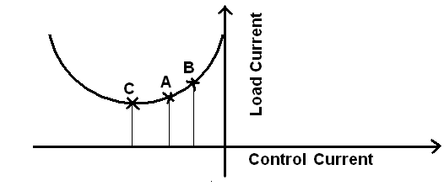
PRECAUTIONS:

1) Do not touch any terminal on the front panel with hands.
2) The instrument should be handled properly.

RESULT:

11.CHARACTERISTICS OF AC SERVOMOTOR

AIM: To plot the speed-torque characteristics of AC servo motor.

APPARATUS:
1) AC servomotor equipment.
2) Probes.
3) Multimeter.

CIRCUIT DIAGRAM:
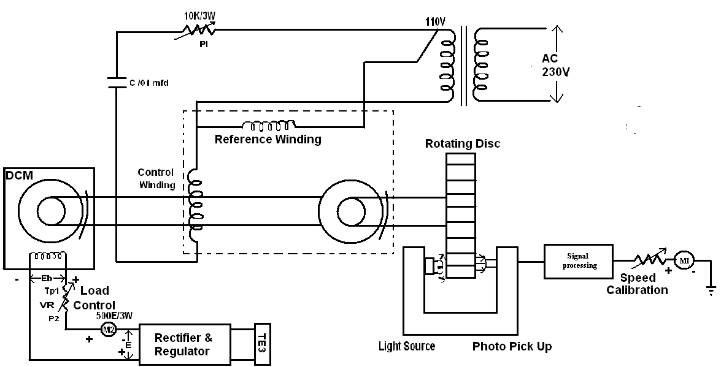

PROCEDURE:

a) Keep the switch Sw3 in upward position on indicating that the armature circuit of DC machine is connected to auxiliary power supply switch sw2 should be off.

b) Ensure P1 & P2 are in fully anti clock wise position, now switch ON sw1 & also on SW2 you can observe that ac servo motor will start rotating & the speed will be indicated by the meter on the front panel.

c) Switch SW3 in off position. Vary the speed of the AC servo motor by moving ‘P’ in clockwise direction & note the EMF generated by the DC machine.

d) Now switch SW# in off position, switch on SW2 & Keep the point P in minimum position .you can observe that the Ac servo motor starts moving with speed being indicated by the rpm indicator. You can measure the reference winding voltage & control winding voltage .Note the speed of the Ac servomotors .now switch on SW3 & start loading AC servomotor by controlling point P2 in a slow fashion. Note down corresponding values on I_{a} & N enter the value.

e)Now you may set control winding voltage to a new value of 30 volts after switching off SW3 .Again repeat the process as indicated in above step i.e ,table 2 a new value of control winding.

- Plot the speed –torque characteristics for various values of control winding voltages.

TABULAR FORM:

S.No | V_{C}  (Volts) | I_{A}  (MA) | Speed  (RPM) | Ed(Volts) | P  (Watts) | T=(Px1.019x10x60)/2πη)
1
2
3
4
5
6

MODEL GRAPH:
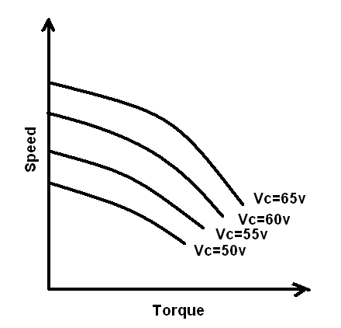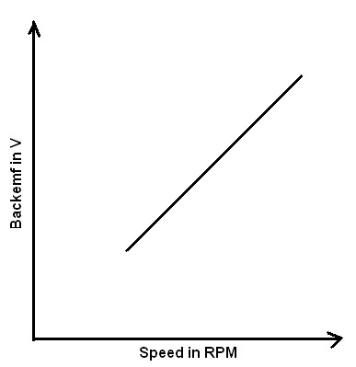

PRECAUTION:

- Connect the probes with out any loose connections.

- The control winding voltage must be set after offing the switch.

- Plot the graph without any error.

RESULT:
12. CHARACTERISTICS OF DC SERVO MOTOR

AIM: To plot the speed torque characteristics of DC servomotor.

APPARATUS: 1) DC Servomotor kit.
2) Multimeter.

FRONT PANEL DIAGRAM:

PROCEDURE:
- Before switch on the instrument, the speed control plot and the load control plot are in fully anti clock wise position.
- Keep the load switch and motor switch in off position.
- Now switch on the instrument, switch on servomotor.
- By using potentiometer P1 set armature voltage (Va) at fixed Va using digital multimeter to measure armature voltage at front panel at Tp1 and note down speed of DC servo motor in Table.
- Now keep P2 at minimum position and switch on the load .switch to apply load on DC servomotor .Note down corresponding current from Dc ammeter. And also note down back emf from Tp3 terminal by using multimeter .Enter the values corresponding the RPM value.
- Repeat step no.5 for different values by varying load control potentiometer p2 in a slow fashion. Note down corresponding values of current Ia, Back emf voltage Eb & Speed N and enter the values in table.
- Now switch off load switch and keep P2 in minimum position & again set armature voltage, Va= Again repeat process indicated in steps 5 & 6.
- Repeat the process in 5, 6, 7 at different values Va and plot the graph speed verses torque of various values of Va.
- Before switching on check that there should be proper earthning and proper connections.
- The speed contol and load control potentiometers should be always in anticlock wise position before switching on the equipment.
- In order to increase armature voltage rotate the knob in clockwise direction in gentle fashion.
- In order to increase load on servomotor .Rotate load control pot in clock wise direction in gentle fasion.
- Before doing experiment check armature voltage and DC machine voltage at Tp1 & Tp3 terminals.
TABULAR FORM:

Armature Voltage Va =4V

S.No | I_{a}  (Amps) | N  (rpm) | Back EMF voltage Eb(V) | Power  P=E_{b}xI_{a}(mw) | Torque  T= (Px1.019x10⁴x60)  2πN (gm-cm)
1
2
3
4
5
6
7
8

Armature Voltage Va =6V

S.No | I_{a}  (Amps) | N  (rpm) | Back EMF voltage Eb(V) | Power  P=E_{b}xI_{a}(mw) | Torque  T= (Px1.019x10⁴x60)  2πN (gm-cm)
1
2
3
4
5
6
7
8
Armature Voltage Va =8V
Armature Voltage Va =10V
S.No | I_{a}  (Amps) | N  (rpm) | Back EMF voltage Eb(V) | Power  P=E_{b}xI_{a}(mw) | Torque  T= (Px1.019x10⁴x60)  2πN (gm-cm)
1
2
3
4
5
6
7
8
S.No | I_{a}  (Amps) | N  (rpm) | Back EMF voltage Eb(V) | Power  P=E_{b}xI_{a}(mw) | Torque  T= (Px1.019x10⁴x60)  2πN (gm-cm)
1
2
3
4
5
6
7
8

MODEL GRAPH:

PRECAUTIONS:
- Before switching ON check that these should be proper earthing & proper connections.
- The speed control & Load control potentiometers should be always in anticlockwise position before switch on equipment.
- Before doing experiment check armature voltage and DC machine voltage at Tp1 & Tp3 terminals.

RESULT:

13. POTENTIOMETER AS AN ERROR DETECTOR

AIM: To study characteristics of positional error detector by angular displacement of two servo potentiometers.

APPARATUS:Potentiometer kit, Dual trace CRO and connecting leads

THEORY: Potentiometric transducers are used in control applications. The set-up has built-in source of +5V dc and about 2Vpp 400Hz AC output. A DVM is provided to read dc voltage and AC can be read on CRO. The potentiometers are electrtomechanical devices which contain resistance and a wiper arrangement for variation in resistance due to displacement. The potentiometers have three terminals. The reference DC or AC voltage is given at the fixed terminals and variable is taken from wiper terminals.

CIRCUIT DIAGRAM:

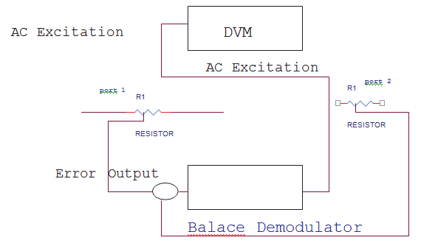

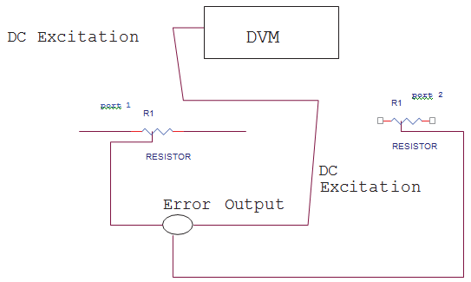

PROCEDURE :

- Connect the power and select the excitation switch to DC. Keep Pot.1 to center=180˚.Connect DVM to error output. Turn Pot.2 from 20˚ to 340˚ in regular steps. Note displacement in 0˚=02 and output voltage E as V₀. Plot graph between V₀ and 0e= 01- 02.
2. Switch ON the power and select excitation switch to AC. Connect one of CRO input with carrier output socket and ground. Connect other input of CRO with error output socket. Keep pot.1 fixed at180˚ and move pot.2 from 20˚ to 340˚. Note displacement in 0˚ and Demodulator voltage V_{DM}. Plot graph between displacement and demodulator voltage.

OBSERVATION TABLE:

Sl.No. | Pot.2 position in 0˚ | 0e= 01- 02 | Output Voltage = V₀

PRECAUTIONS :
1. Select the excitation switch as required, AC or DC. Wrong selection may cause error experiment or damage the setup.
2. Take the reading carefully.
3. Switch OFF the setup when not in use.

GRAPH:-
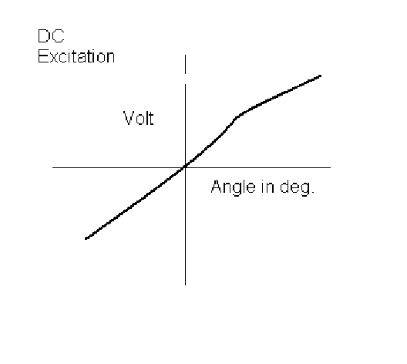
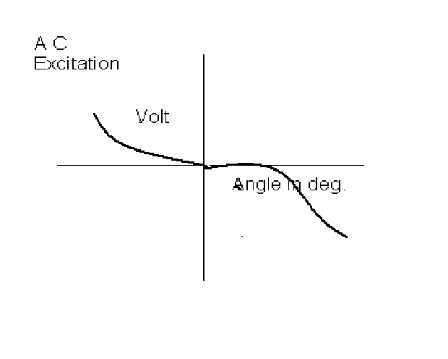

RESULT:
The graph is plotted between displacement angle and output voltage. For DC Excitation the output voltage increases linearly with positive displacement angle and decreases with negative displacement angle. but for AC excitation it is reverse. The output voltage increases with negative displacement and decreases with positive displacement angle.

